

Data Technician

Name:
Course Date:
Table of contents
Day 1: Task 1 2
Day 2: Task 1 2
Day 2: Task 2 3
Day 2: Task 3 4
Day 3: Task 1 4
Day 3: Task 2 5
Dataset: 5
Step 1: Create a Pivot Table 5
Step 2: Use the SWITCH Function 5
Submission: 6
Day 3: Task 3 6
Day 4: Task 1 7
Course Notes 9
Additional Information 10

Day 1: Task 1

Please research and complete the below boxes on common laws and regulations that must be followed when working with customers data, use the below bulleted list to support your answers.

- What is it
- Why is it important
- Provide a real-world example of how you can follow it
- How does it impact working with data
- What could happen if you breached it

Data Protection Act | - What is it  UK Law regulating how personal data is collected/stored/used  - Why is it important  Protect individuals’ privacy  - Provide a real-world example of how you can follow it  The staff member doesn't disclose the student's personal data because the parent is not the authorized recipient, making it unlawful and unfair.  - How does it impact working with data  Only use data for the explicit, legitimate purposes, for which it is collected  - What could happen if you breached it  Fines of up to £17.5 million or 4%of annual turnover
GDPR | - What is it  It is an EU data privacy and security law that came into effect in May 2018.  - Why is it important  It gives people greater control over their personal information, including the right to know what data is collected, how it's used, and the ability to correct or request its deletion.  - Provide a real-world example of how you can follow it  E-commerce websites collecting necessary data for the specific purpose of sending newsletters and doesn’t ask for unnecessary information  - How does it impact working with data  GDPR sets out rights that allow individuals to manage their personal data, request access to it at any time, and ask for its deletion.  - What could happen if you breached it  Breaching GDPR can result in large fines, mandatory reporting to the Information Commissioner’s Office (ICO), and the potential for private legal action by affected individuals.
Freedom of Information Act | - What is it  The Freedom of Information Act 2000 provides public access to information held by public authorities.  - Why is it important  The Freedom of Information (FOI) Act holds public authorities for their actions and decisions by allowing the public to see the information that underpins their work.  - Provide a real-world example of how you can follow it  Determine which public authority holds the information  - How does it impact working with data  - What could happen if you breached it
Computer Misuse Act | - What is it  - Why is it important  - Provide a real-world example of how you can follow it  - How does it impact working with data  - What could happen if you breached it

Day 2: Task 1

Please research and complete the following tasks within the retail-sales_dataset.xlsx document, paste a print screen into the provided boxes below:

- In the sheet ‘retail_sales_dataset’ add all available data between columns A – J into a ‘Table’. Remember to select only the data you want to convert.
- Using the dropdown menu in the ‘Age’ column, sort the data by age, ‘largest to smallest’
- Using the ‘SUM’ function, show me the commission total in cell ‘M10’
- Using the ‘AVERAGE’ function, show me the average commission in cell ‘M11’

Print screen 1 | 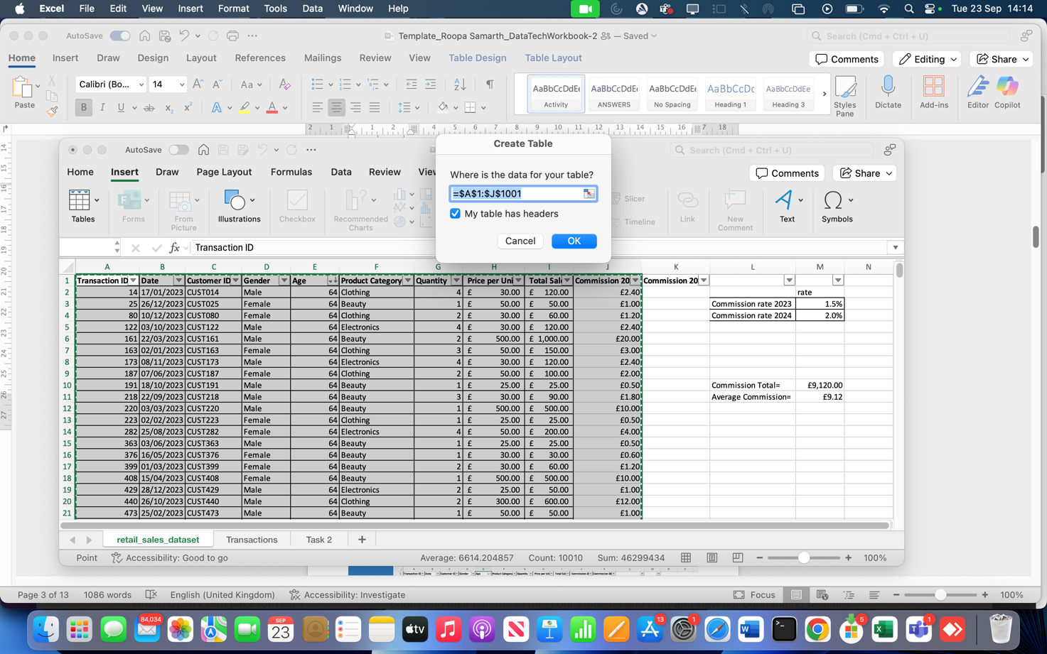
Print screen 2 | Sort by Age from Largest to Smallest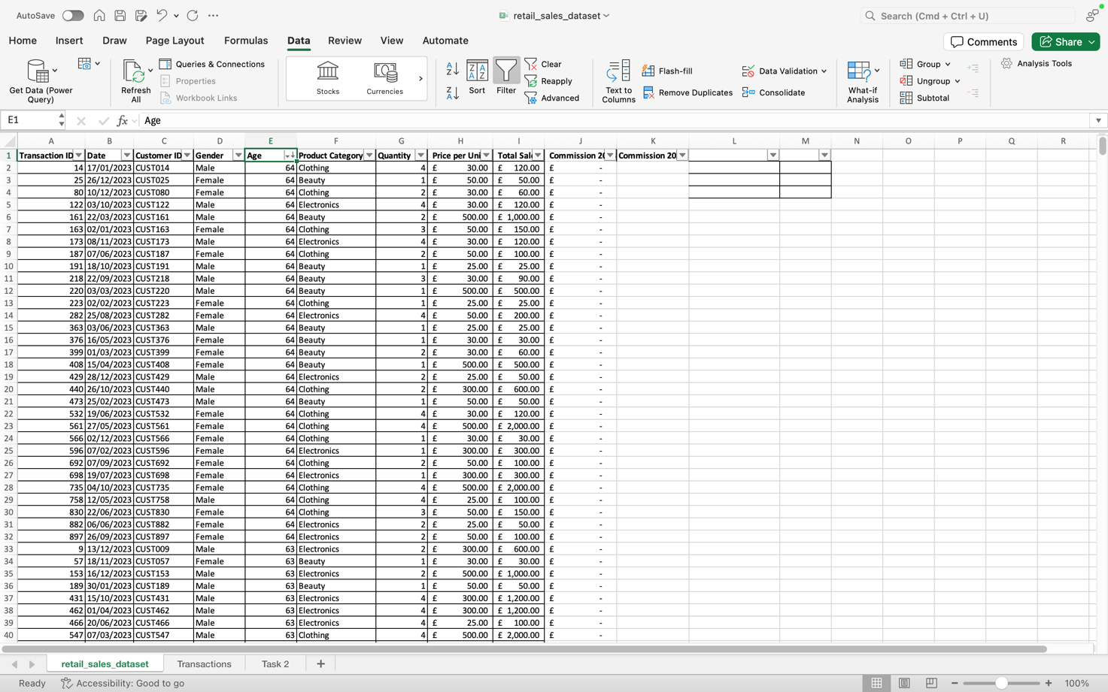
Commission Total
Print screen 3 | 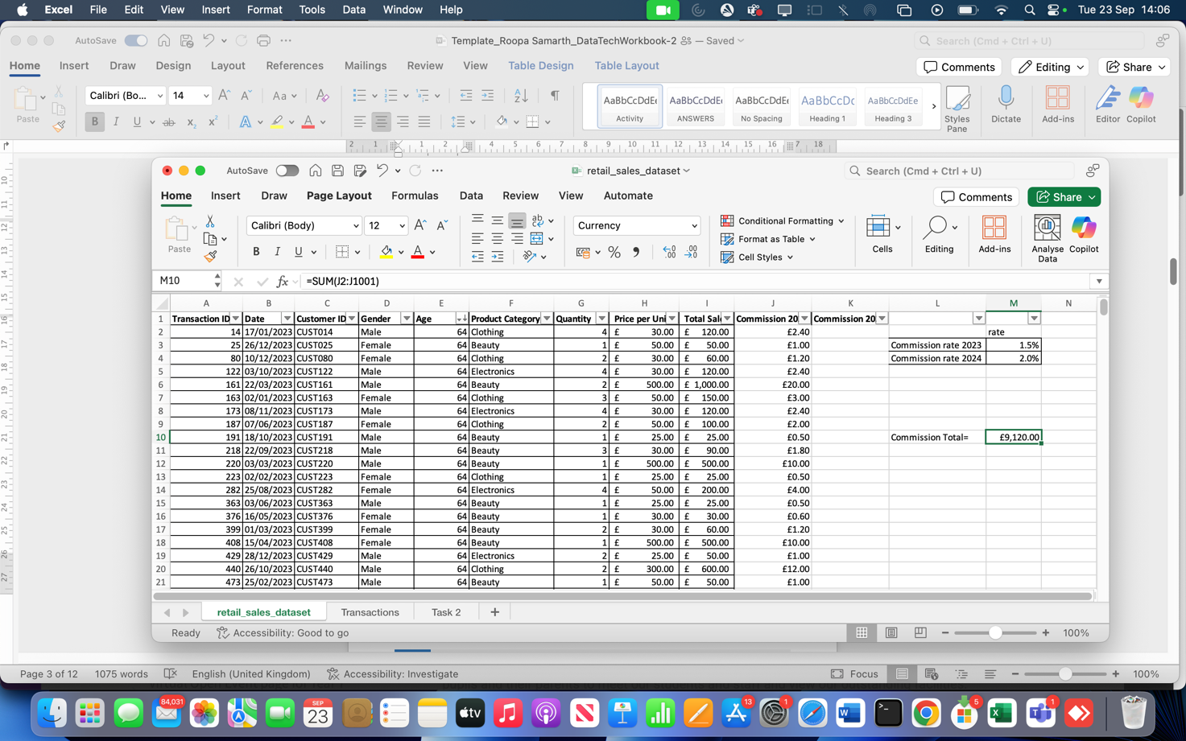
Print screen 4 | Average Commission  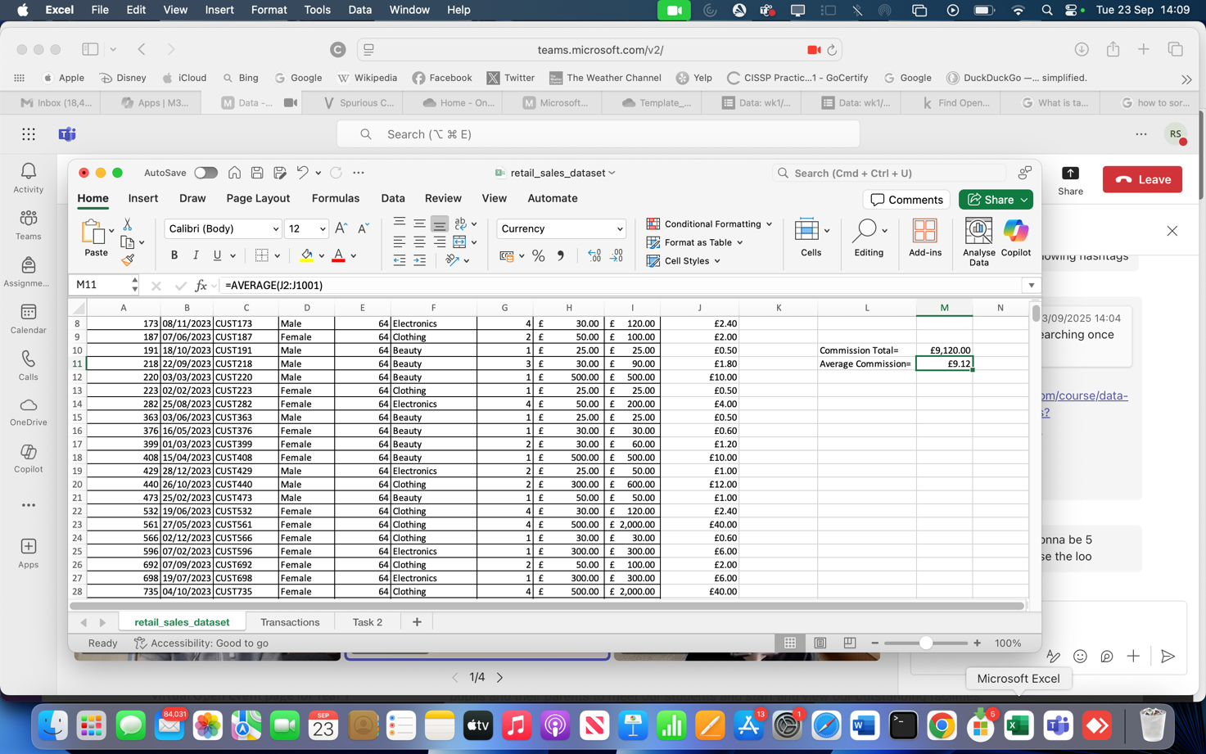

Day 2: Task 2

Please research and complete the following tasks within the retail-sales_dataset.xlsx document, paste print screens into the provided box below:



Print screen 1 | 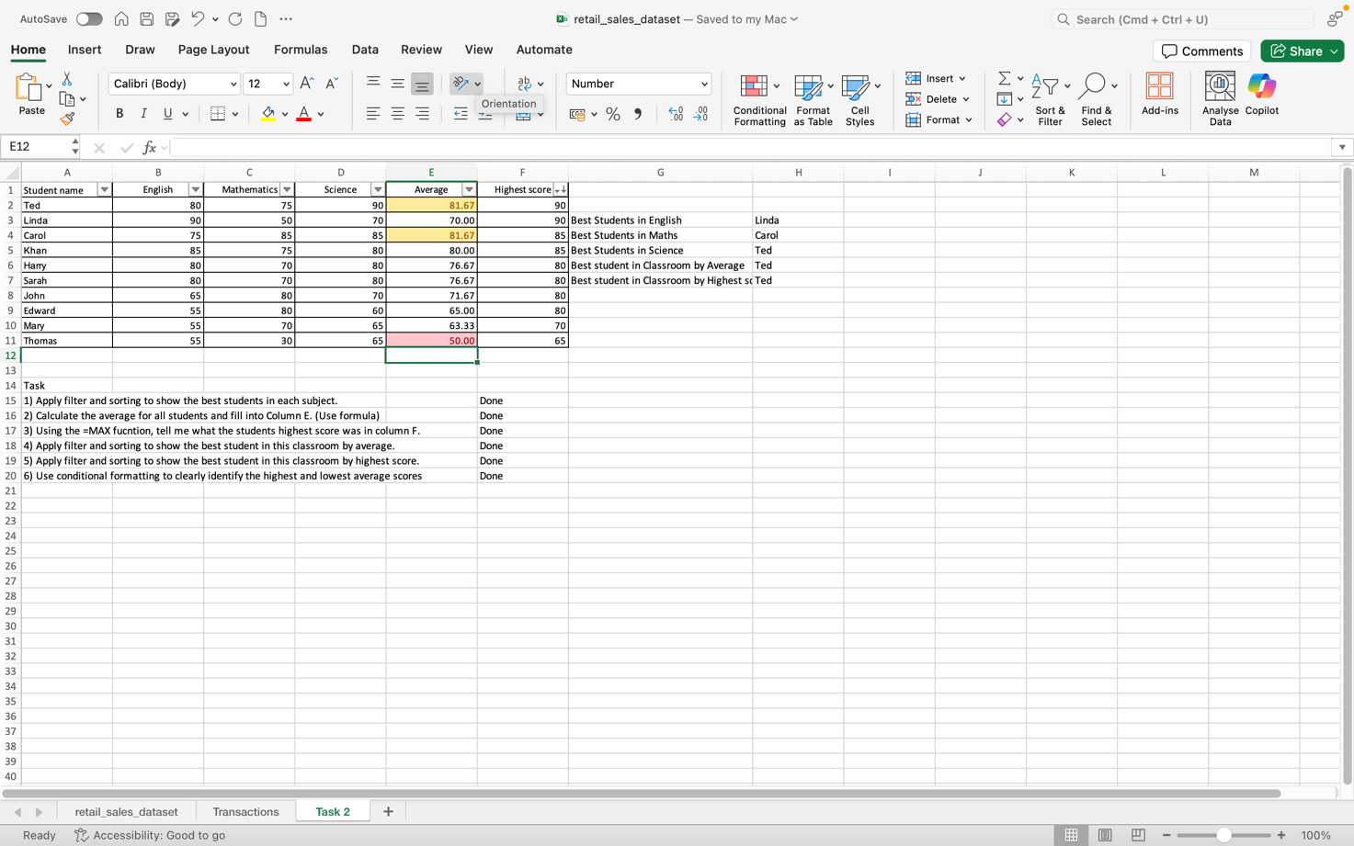

Day 2: Task 3

Using the skills developed today, have some fun with the data set you have imported. Paste your work below and enjoy!

Print screen 1

Day 3: Task 1

Please download the dataset ‘Day_3_Task_1_Bike_Sales_Pivot_Lab.xlsx’ from here.

The lab instructions can be found here. Do not worry if you do not complete the lab, just working with data and playing with the pivot table will be good experience.

Please paste your final pivot table below and complete the reflection questions:

Print screen 1 | 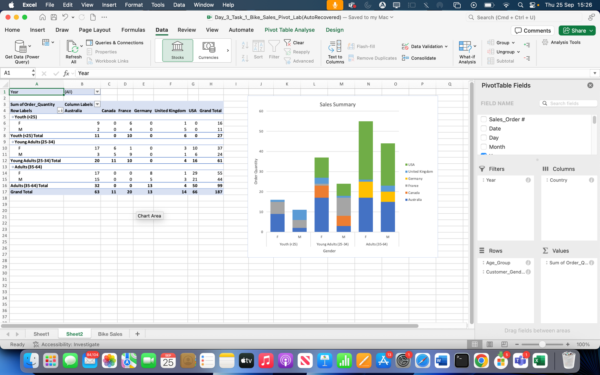
In which markets does Germany have customers? | Germany has market between the age group of 35-64
What country has sales in all markets? | Australia has sales in all markets
What are the most profitable markets by country, age group, and gender? | United States has most profitable market by Female age groups between 35-64
Any other findings? | Germany has very less presence in the age group from 0 to 34 years

Day 3: Task 2

The dataset below tracks the sales performance of different products in various counties in England. Please paste the dataset into a blank Excel workbook. Your task is to:
- Create a Pivot Table to summarise the data by county and product.
- Use the SWITCH function to categorise products based on their sales volume.

Dataset:
County | Product | Sales Volume
Yorkshire | Laptops | 500
Yorkshire | Smartphones | 200
Cornwall | Laptops | 700
Cornwall | Printers | 400
Lancashire | Smartphones | 150
Lancashire | Laptops | 600
Essex | Printers | 800
Essex | Smartphones | 300
Durham | Laptops | 250
Durham | Printers | 300
Greater Manchester | Smartphones | 600
Greater Manchester | Laptops | 400

Step 1: Create a Pivot Table
- Select the dataset (columns A to C).
- Insert a Pivot Table to summarise the data by County in the rows and Products in the columns. Use Sales Volume as the value to be summarised.

Step 2: Use the SWITCH Function
In a new column next to your data, use the SWITCH function to categorise products based on Sales Volume as follows:
  - For sales greater than 600: "High"
  - For sales between 300 and 600: "Medium"
  - For sales less than 300: "Low"
SWITCH Function Example:
=SWITCH(TRUE, C2 > 600, "High", C2 >= 300, "Medium", "Low")
- Apply this formula to each row, and check if the products are categorised correctly.
- In ‘Sales Volume’ you need to remove the space after each amount
- Confirm the data type is numerical

Submission:
- A completed Pivot Table summarising sales by county and product.
- A new column in the dataset categorising products by sales volume using the SWITCH function.
  - Please paste your completed work below

Print screen 1

Day 3: Task 3

Please download the dataset ‘Day_3_Task_3_Bike_Sales_Visualisations_Lab.xlsx’ from here.

The lab instructions can be found here. Do not worry if you do not complete the lab, just working with data and playing with the charts will be good experience.

Please paste your results below:

Print screen 1

Day 4: Task 1

You have been asked to deliver your analysis findings to the board of directors, within your analysis you have identified that customers are leaving your company at the 12-month point, this is typically when they receive their renewal price.

Conduct research and complete the below questions:

How would you prepare for the delivery?
What tools would you use for the delivery?
What is prospecting and why would you complete this before your delivery?
Tell me best practices for public speaking and providing updates to senior leaders
What will you show the board in your delivery?
How will you articulate the changes that are needed?
Provide a list of online resources and videos that will support your preparation for public speaking
Evaluate tools that provide visualisation.

Tell me what they are.

Tell me what you would choose when delivering your presentation and why

Course Notes

It is recommended to take notes from the course, use the space below to do so, or use the revision guide shared with the class:

Additional Information

We have included a range of additional links to further resources and information that you may find useful, these can be found within your revision guide.

END OF WORKBOOK

Please check through your work thoroughly before submitting and update the table of contents if required.

Please send your completed work booklet to your trainer.

